NJ-02
2016 IE Strategy Memorandum

Updated on 5/17/16

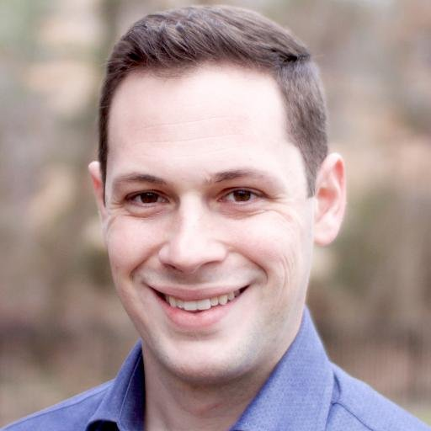

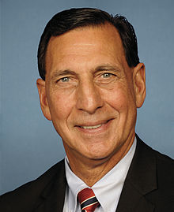

DAVID COLE FRANK LOBIONDO
CoH: $6,455.18 CoH: $855,742.06
Date: 4/15/16 Date: 4/15/16
Occupation: Entrepreneur/Engineer Occupation: Congressman

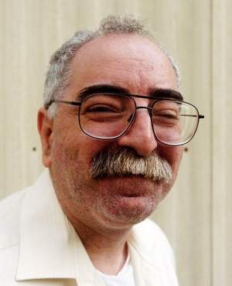

CONSTANTINO ROZZO
CoH: $0
Date: 4/15/16
Occupation: Labor Activist



ERIC BEECHWOOD
CoH: $0
Date: 4/15/2016
Occupation:

SECTION I: Race Overview

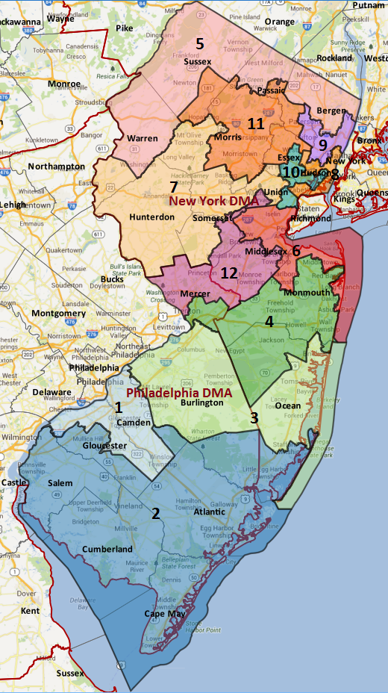

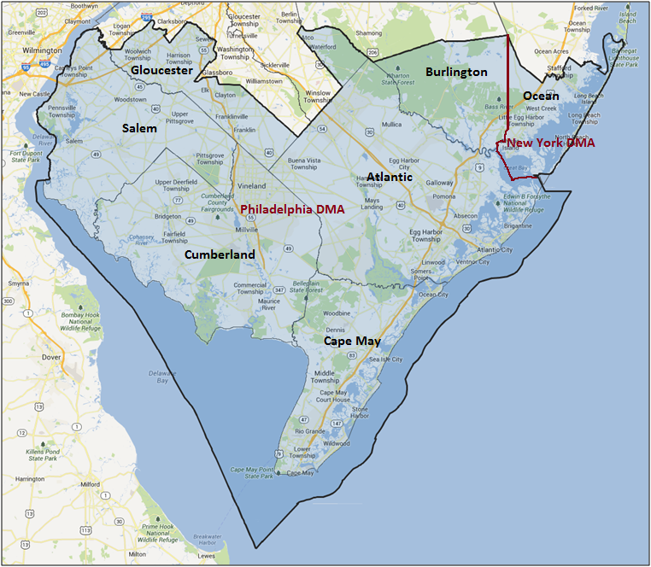

Media Market Costs

TV DMA | % of  CD | I.E.  35+ CPP | Cable CPP
PHILADELPHIA | 94% | $756
NEW YORK CITY | 6% | $2079
NJ-02 TOTALS: | 100.0%
Digital Landscape
  - Persuasion universe size: 43,992
  - Audience extension (key demos): Independents & Democrats
  - Weekly budget for full coverage: $11,921.88
  - Reach
    - YouTube - 351,518
    - Pandora - 211,670

Presidential Statistics
Cycle | Candidate | Party | Vote
2012 | Obama | DEM | 54.1%
2012 | Romney | REP | 45.9%
2008 | Obama | DEM | 53.8%
2008 | McCain | REP | 46.2%

Congressional Statistics
Cycle | W/L | Candidate | Party | Vote
2014 | L | HUGHES | DEM | 37.7%
2014 | W | LOBIONDO | REP | 62.2%
2012 | L | SHOBER | DEM | 41.2%
2012 | W | LOBIONDO | REP | 58.8%

NCEC Data
Dem Performance: 51.4%
BVAP: 12.6%
Hispanic: 9.2%
Asian: 2.8%
Total Minority: 24.6%

Critical Dates
Filing Date: May 30th, 2016
Primary Date: June 7th, 2016

Pre-Election Day Voting

Type of  “Early Voting” | Start Date  End Date | Percent of  Vote Cast Using this Method | Brief Description  (where/how  do people vote) | Timeframe (when does the majority of voting happen)
Early Vote | Oct 8 –Nov 8 |  | Voters can bring their early ballots to the board of elections office or be issued a ballot at the office at the time of their visit
VBM Absentee Ballot/In person Absentee | Received by 8pm on Nov 8th |  | Voters must apply for an absentee/VBM ballot via mail, online, or in person

